Game Design Concepts

# Game Concept

The general game concept consists in a “Lobby” environment entered by the player at the starting of the game; the Lobby directs the player towards different areas (one for each topic of the trainings) containing different mini-games.

The mini-games have different difficulties and can be accessed only if the ones with lower difficulty have already been successfully completed (Progressive advancement concept).

At the end of each topic area, we thought of designing a mini-game that aim to summarize the concepts introduced during the training (much like a final examination that can also be used as a knowledge-refresh mini-game for annual re-examinations).

# Reward System

There are several ways how a player can be rewarded for his good work. The player can get a virtual trophy, a real trophy or an in-game currency.

A virtual trophy is like a virtual badge that the player gets for certain achievements. These achievements could for example be:  
- Basic knowledge – completing the basic necessary courses

- Master of compliance – achieving > 80% for all compliance games

The goal of these badges is to create a certain satisfaction and pride for the player.

A real trophy would be a cup or a challenge-cup, which will be rewarded to either the best player or the best department. To further enhance the competition that is created by this system, leaderboards of the scores should be posted on screens or notice boards.

The last reward system is based on an in-game currency. Getting higher scores in the game will give you more currency, which then can be used to for example:

* decorate or improve an in-game location
* Buy help in mini-games
* Improve in-game skills (in a RPG)

# Gameplay Concepts

Here we present some concepts of the mini-games’ gameplay.

## Point and Click

The proposed gameplay is in the form of a point and click adventure game. The player may interact with objects in the world and NPCs with mouse clicks.

Here two different implementations can be adopted:

- the view is fixed and the player can only click on objects and people in order to interact with them (1st person view).

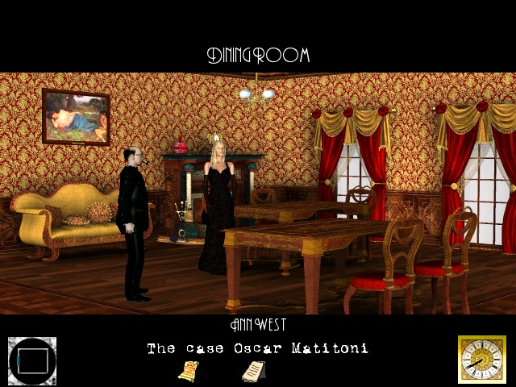

- the player can move around the world and interact with it by clicking on objects (3rd person view).

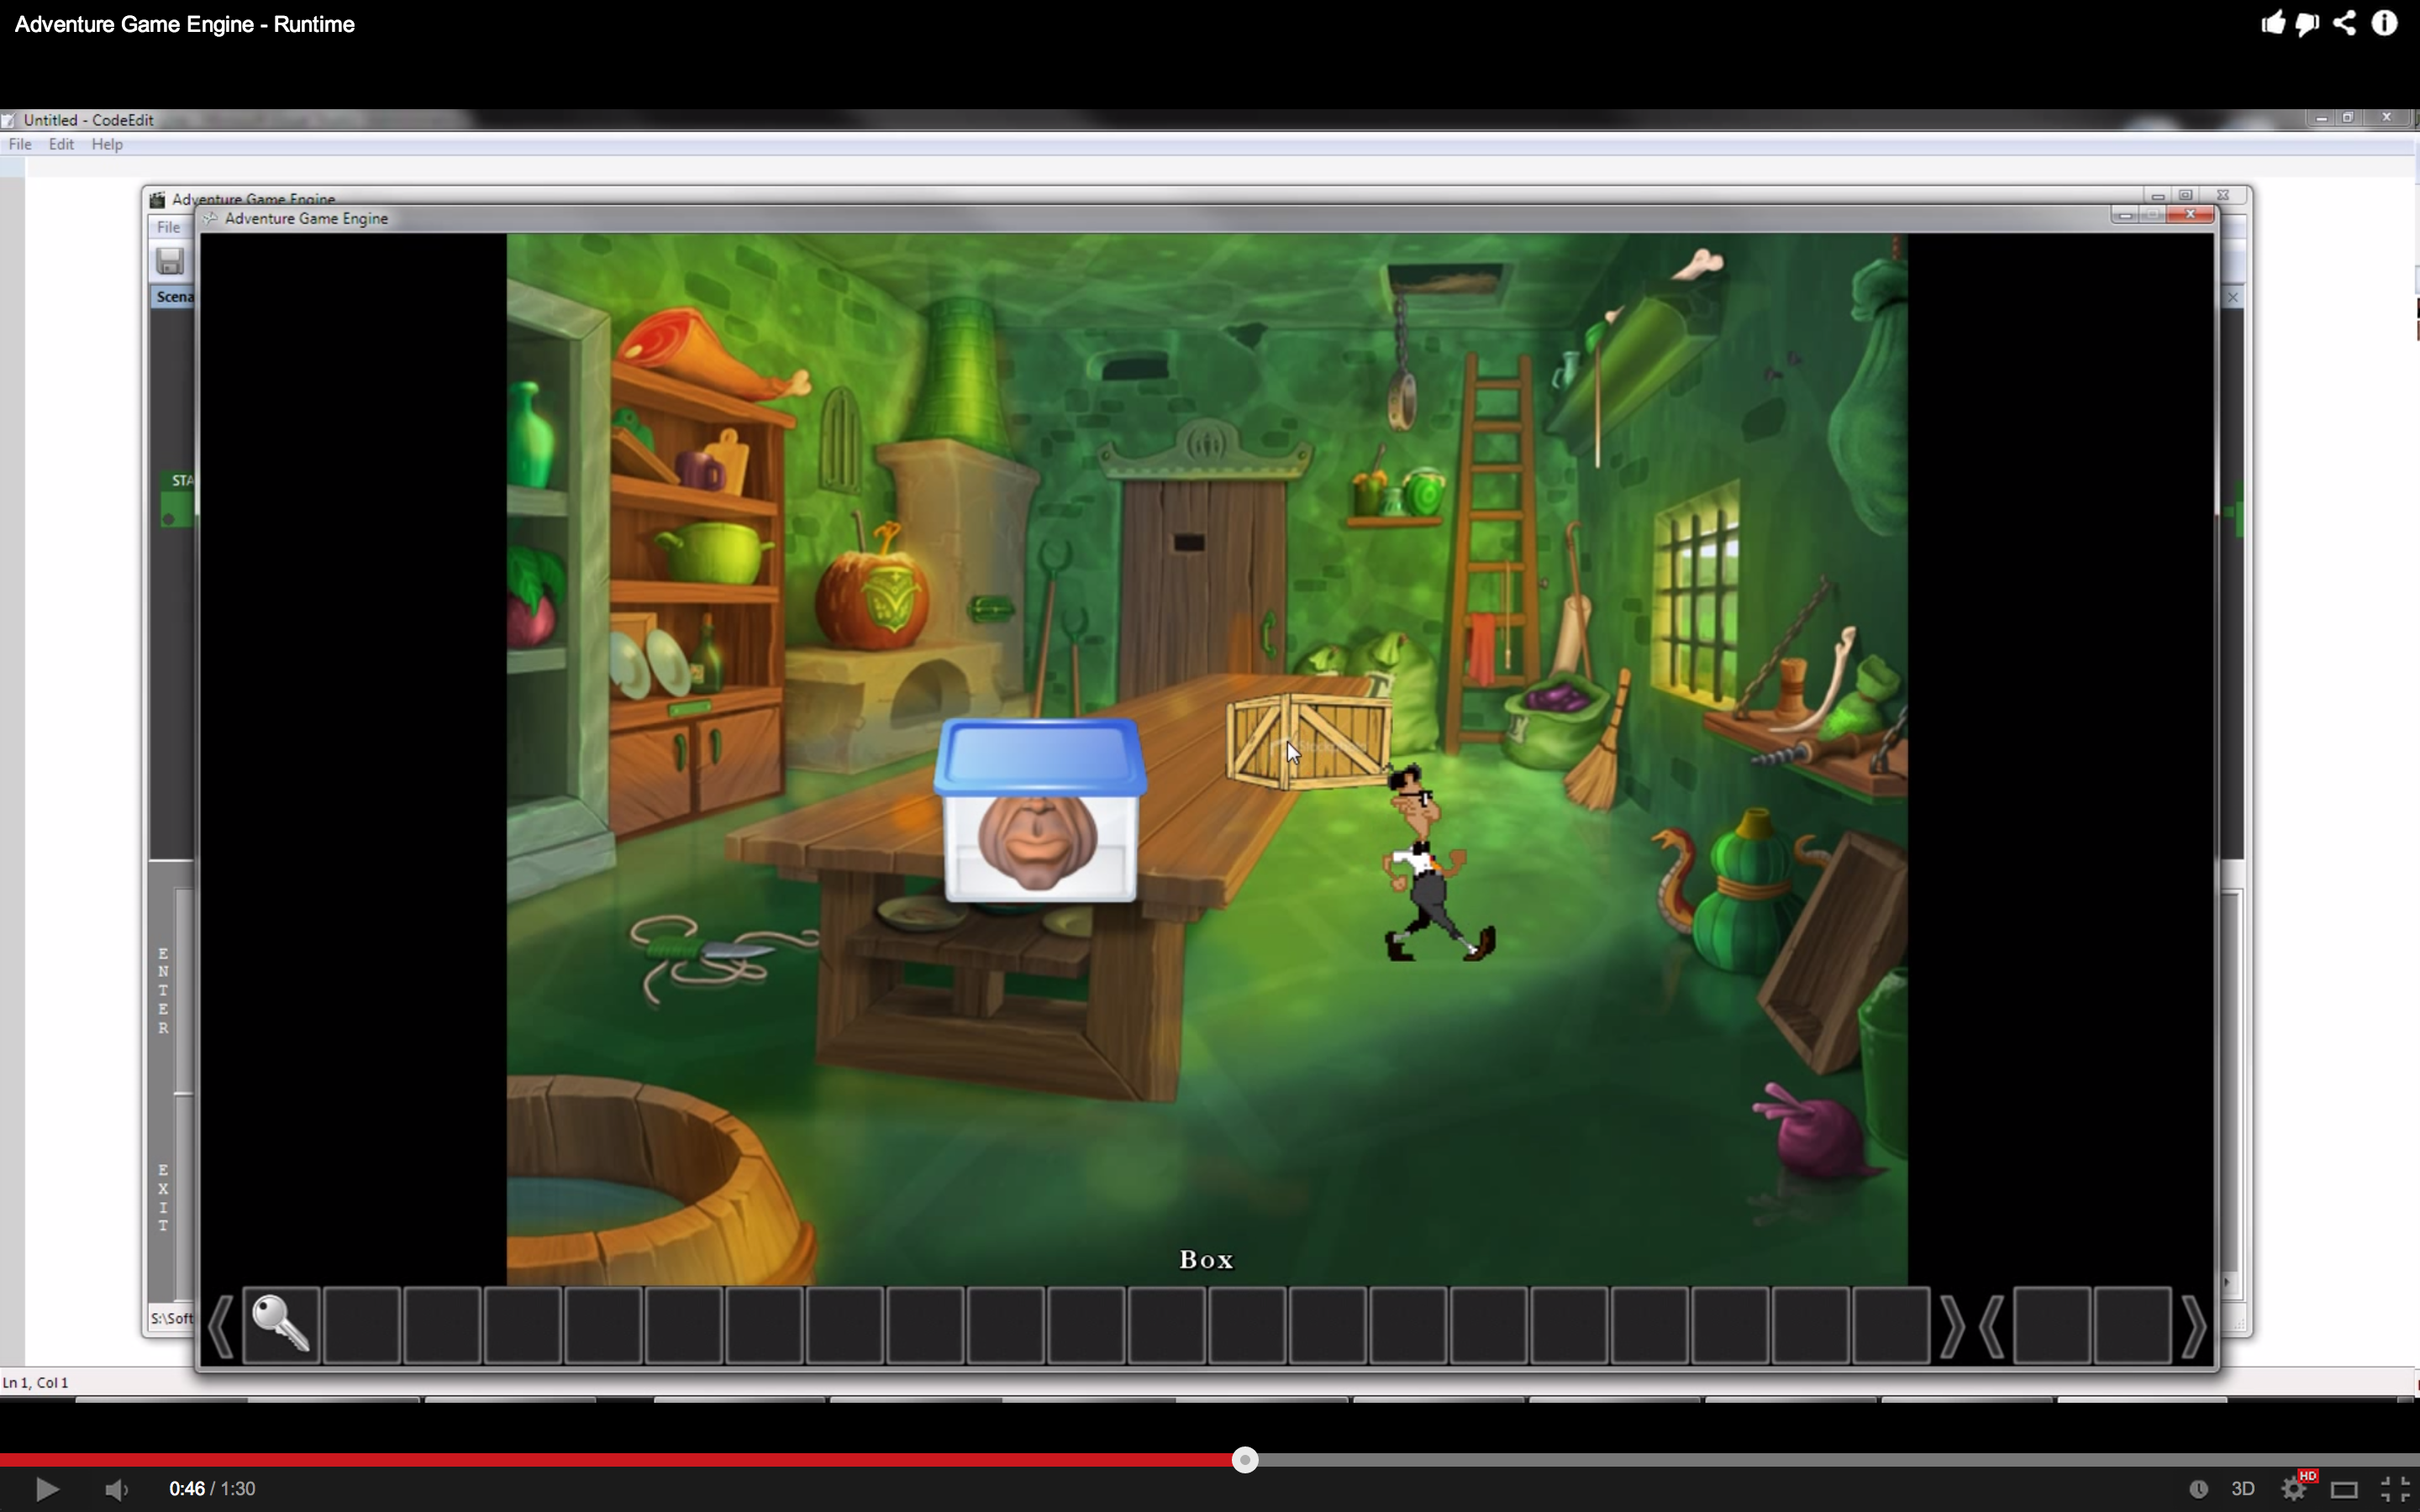

### RPG

This solution involves movements only with keyboard and a top down 2d environment. (The figure below is only an example, the graphics are too old)

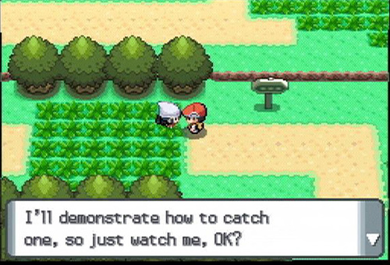

# Lobby Concepts

We present now some ideas for the Lobby we introduced above.

## Static Lobby

A static lobby contains “folder-like” areas each of witch contains a list of mini-games that can be accessed by the player, much like angry birds.

We thought of a static lobby that divides the various topics in a similar way to Angry Birds:

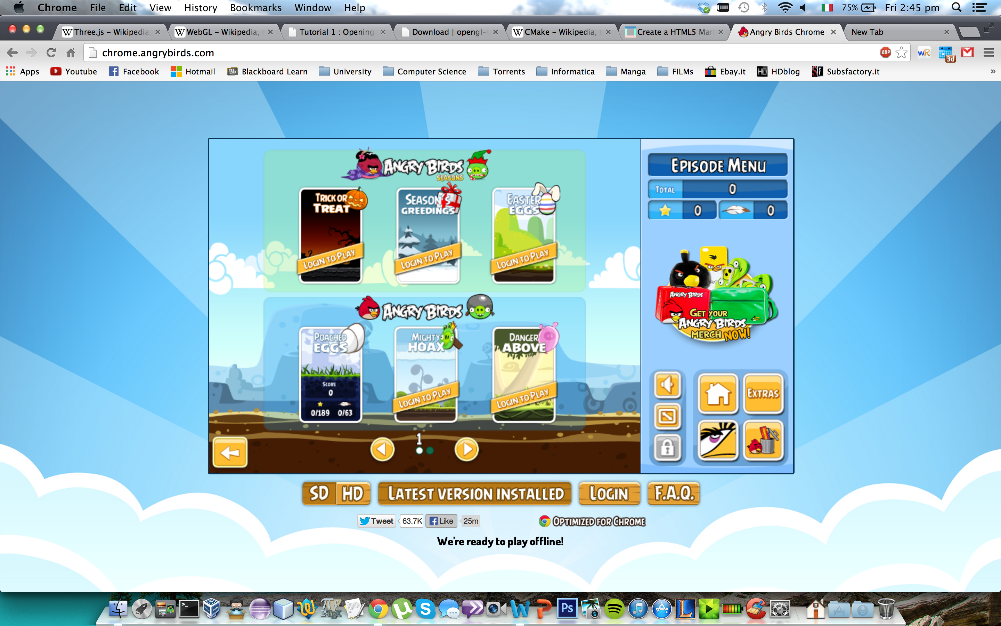

Inside each of these topic-folders the user can choose the level in a way similar to the following one:

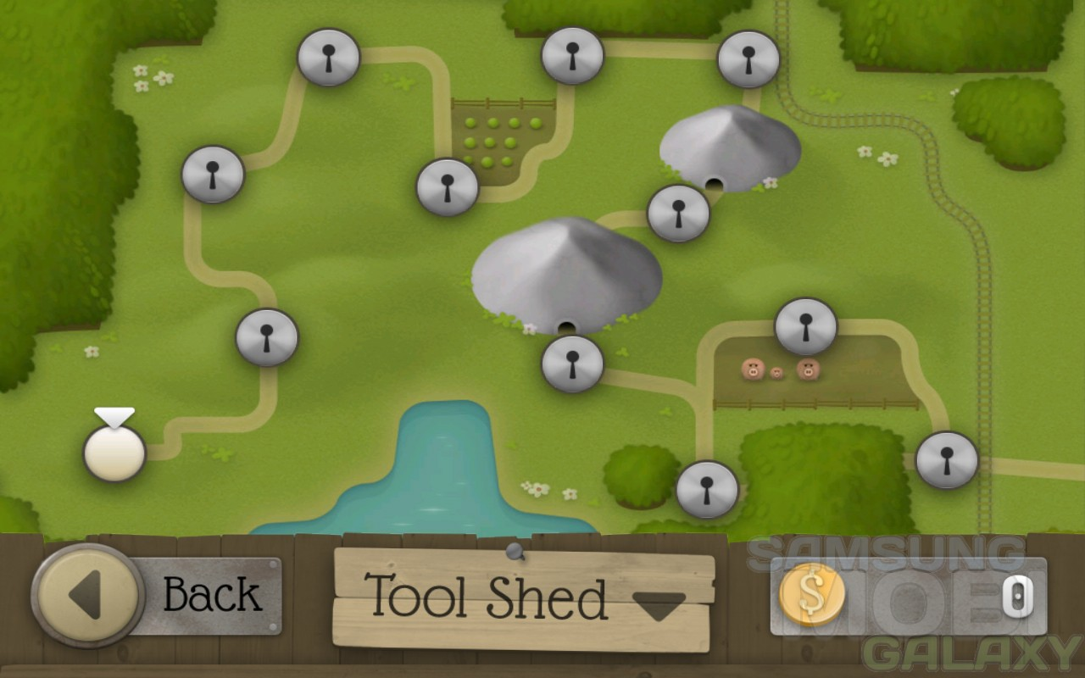

Therefore simulating a “path” from easy trainings to more difficult trainings in the chosen topic.

Since in this case the player cannot in any way personalize the lobby environment, we thought of the possibility of associating an avatar with the account, that can be personalized depending on scores and rewards from the mini-games.

## Game Lobby

A game lobby is set in a real world-like environment that the user can interact with and choose the various mini-games from. It is also possible to change and personalize the environment based on scores and/or rewards from the mini-games.

An example could be that of the game “Crash Bandicot 3” in which you start the game in a castle environment that you can freely explore and choose the levels by entering different portals in different areas of the castle.

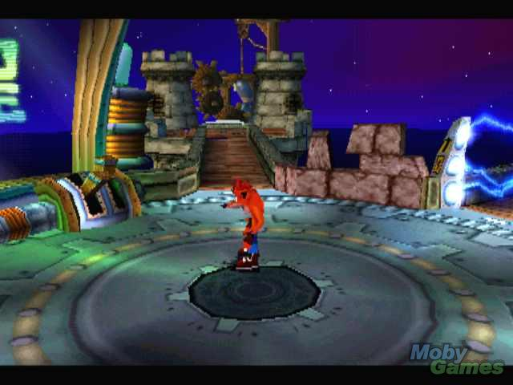

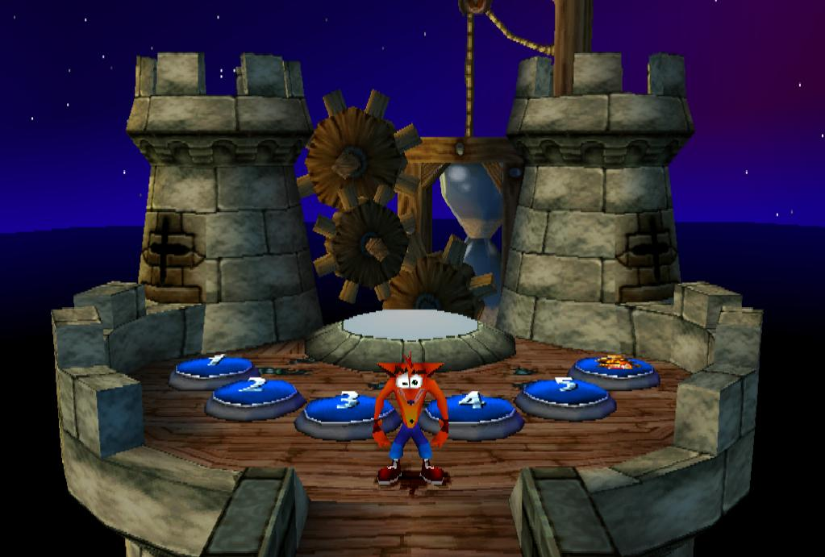

Another example could be that of the Pokemon Games in which, instead of starting a mini-game from a fixed environment element, you start it by talking to different NPCs (quest-like concept):

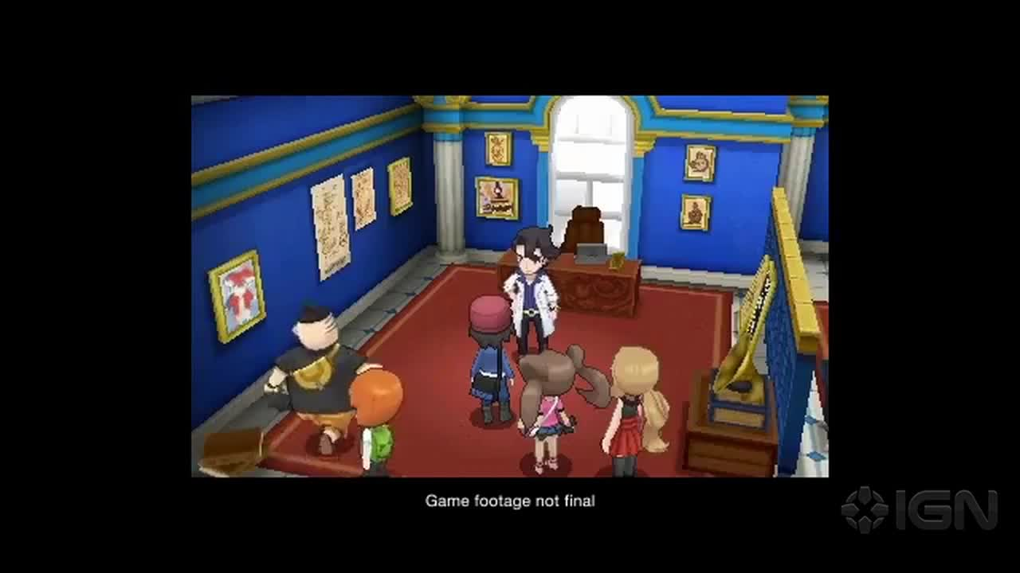

## Dynamic lobby

A dynamic lobby combines the flexibility of a game lobby with the simplicity of a static lobby.

The lobby consists out of a fixed view on an important part of the story, for example an office or a garden. In that screen, there are certain items or buttons that, just like in a static lobby, will start a specific mini-game. What makes the lobby dynamic is that the environment reacts on your scores. For example if you do well, the garden will flourish, whereas if you have do not do well, the garden will die.

The lobby could be closer to the game-lobby by letting the player customize the part in view, or go closer to the static lobby by just changing the background image depending on the scores.